Presented by Community Grief Support
Back Forty Beer Company | April 25th, 2021 | 1-4 PM
macfestbhm.com

Community Grief Support has provided comfort and hope for Birmingham and surrounding communities for twenty-three years. Five years ago, our Junior Board cooked up an idea for a fundraising event – and why not create it around the ultimate comfort food, macaroni and cheese?
Ticket holders get the chance to sample a wide variety of mac n’ cheese from approximately thirty local eateries. With some friendly competition, live music, kids zone, and pet-friendly venue, we expect over 5,000 in attendance this year!
All proceeds benefit Community Grief Support to fund free grief counseling, loss-specific grief support groups, and grief education in the Greater Birmingham area. Donations are tax deductible.

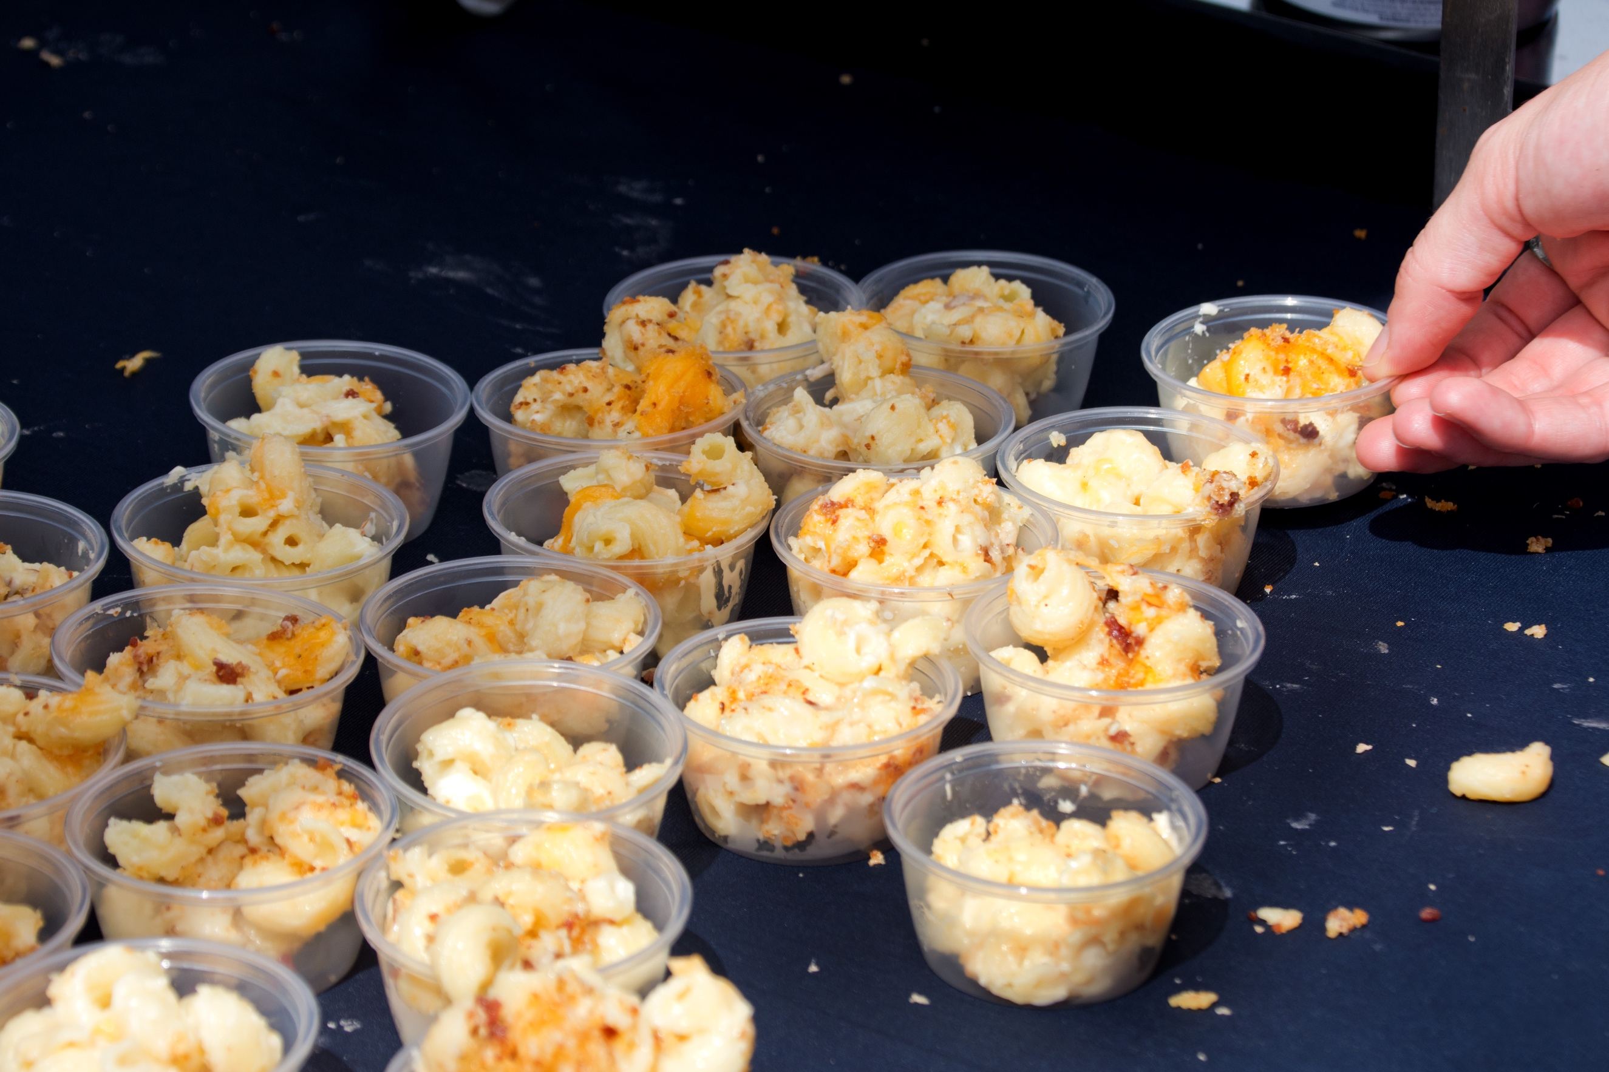
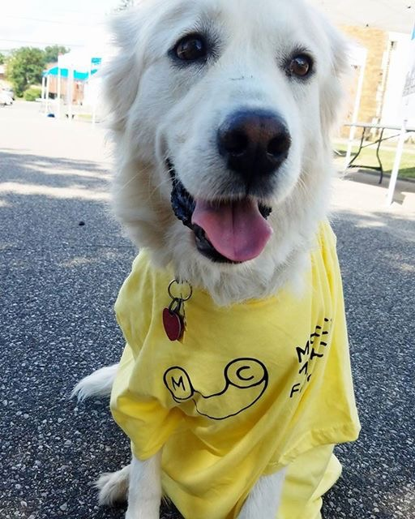
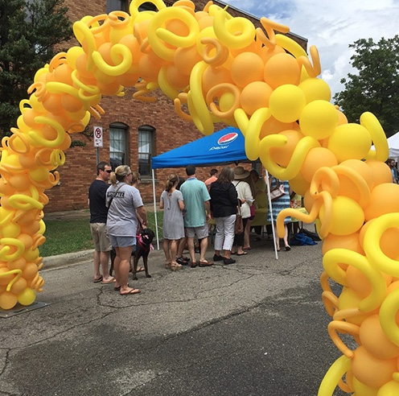

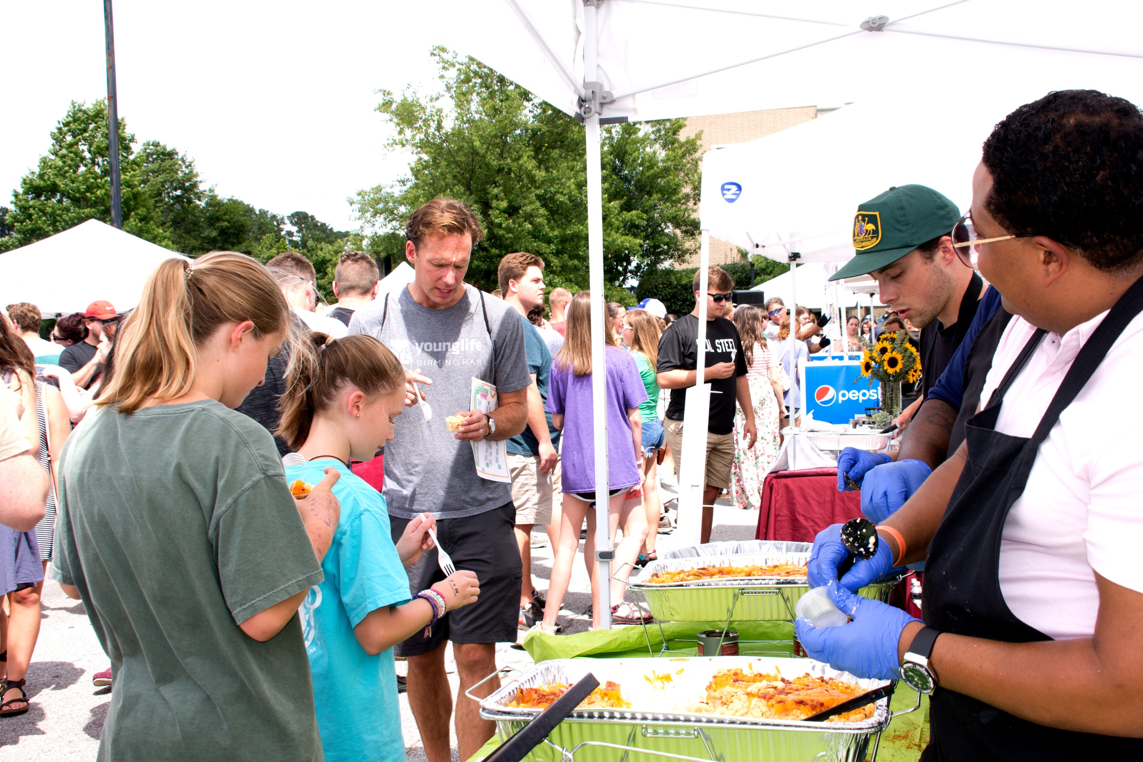
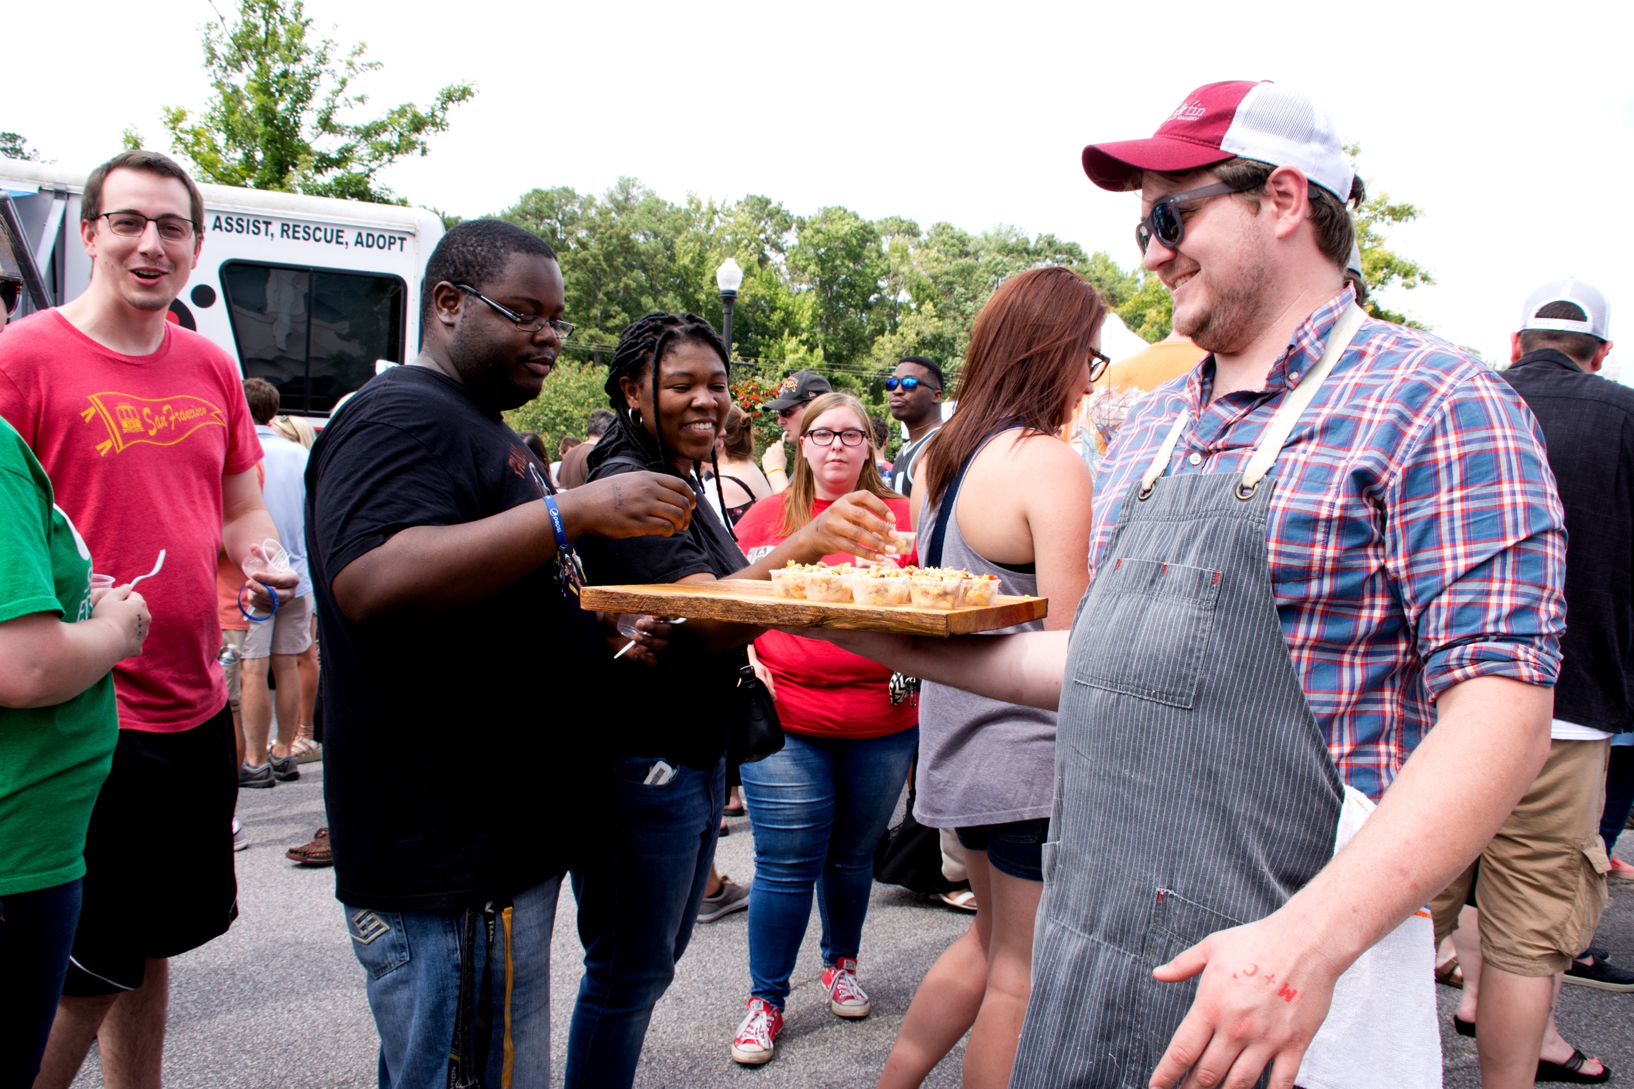
2021 Sponsorship Opportunities

$1500 Gold Sponsor
- Eight admittance tickets
- Company name and logo displayed on banners inside the venue
- Opportunity to provide judge for the tasting competition
- Verbal recognition from stage during event
- Inclusion in three social media advertisements via CGS and Brookwood Village
- Company name and logo on event website
- Recognition in email newsletter with over 1,500 subscribers
$500 Silver Sponsor
- Six admittance tickets
- Company name and logo displayed on banners inside the venue
- Opportunity to provide judge for the tasting competition
- Inclusion in three social media advertisements via CGS and Brookwood Village
- Company name and logo or individual name on event website
$250 Bronze Sponsor
- Four admittance tickets
- Company name and logo displayed on banners inside the venue
- Opportunity to provide judge for the tasting competition
- Inclusion in three social media advertisements via CGS and Brookwood Village
- Company name and logo or individual name on event website

$5000 Presenting Sponsor
- Fifteen admittance tickets
- Fifteen event t-shirts
- Company name and logo prominently displayed
on main banner at event
- Company name and logo prominently displayed
on event t-shirts
- Additional naming – Kids Zone Sponsor,
Stage Sponsor, and Judges’ Tent Sponsor
- Opportunity to provide judge for the tasting
competition
- Verbal recognition from stage during event
- Inclusion in all press releases, radio interviews, and
radio shout-outs
- Inclusion in all social media advertisements via
CGS and Brookwood Village
- Company name and logo on event website
- Recognition in email newsletter with over 1,500
subscribers

$2500 Platinum Sponsor
- Ten admittance tickets
- Eight event t-shirts
- Company name and logo displayed on banners inside the venue
- Opportunity to provide judge for the tasting competition
- Verbal recognition from stage during event
- Inclusion in three social media advertisements via CGS and Brookwood Village
- Company name and logo on event website
- Recognition in email newsletter with over 1,500 subscribers

Your generous sponsorship makes
this community-wide event possible.

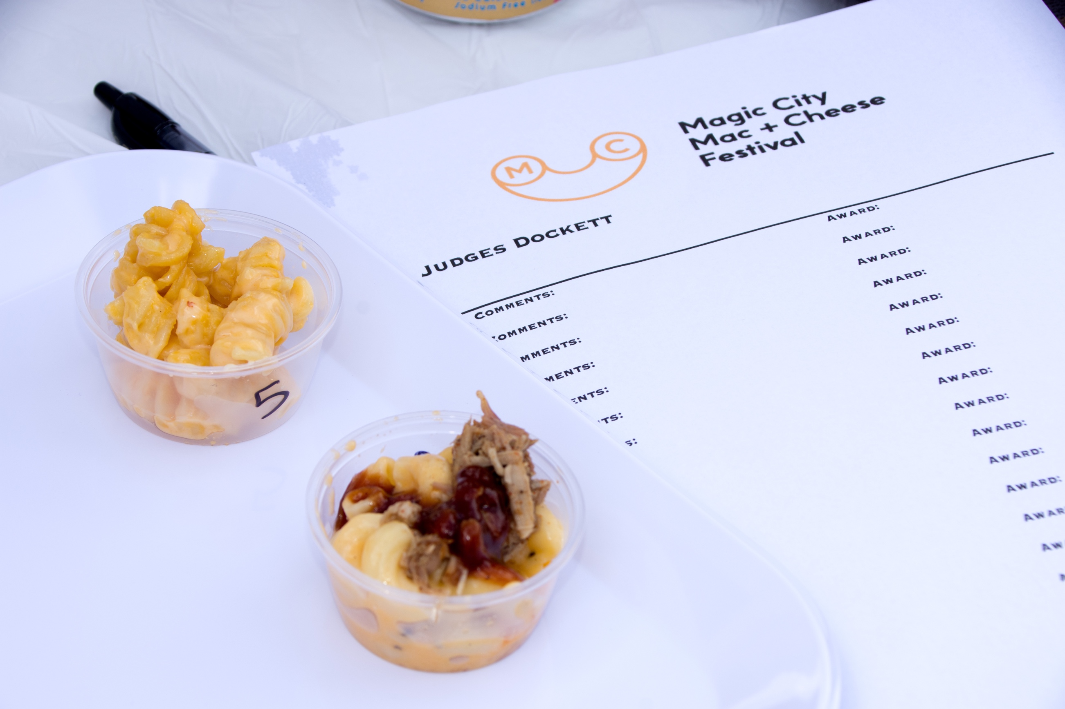
Sponsor Response Form
To: Lisa Harrison
Community Grief Support
1119 Oxmoor Road
Birmingham, AL 35209

Company/ Donor Name
Company Contact
Mailing Address
City State ZIP
Phone Email

Sponsorship Agreement
___________________________

_______________________

Payment Information
- Enclosed is a check for $ made payable to Community Grief Support
- I would like to pay Community Grief Support the amount of $ by credit card
☐ MasterCard ☐ Visa ☐ American Express ☐ Discover
Card Number
Expiration Date Security Code ZIP
Name on Card
Signature
____________________________

___________________________

We Want to Sponsor Community Grief Support’s 4th Annual Magic City Mac N’ Cheese Festival at the Following Level:
- $5000 Presenting Sponsor
- $2500 Platinum Sponsor
- $1500 Gold Sponsor
- $500 Silver Sponsor
- $250 Bronze Sponsor

For recognition purposes, please list contributor name as: _____________________________________________

2021 Magic City Mac + Cheese Festival
Impressions Forecast

Forecasted impressions for the 4th Annual M + C Festival are listed below:
5,000 guests 200 posters

5,000 users 7,500
8,000 hits email blasts

8,000 likes 5,000
25,000 reached newsletters
30,000 impressions

160,000 readers 100,000
listeners

100 lawn signs 400 t-shirts

3,000 tickets printed 120,000
viewers

477,000 total forecasted impressions based on 2019 festival publicity.

COMMUNITY GRIEF SUPPORT
F I N D IN G HO PE TO GE T H ER

